Research Specifications

Concept Overview

The app of my choosing is a Restaurant app that allows the user to find a place to go out to. The app’s goal is to allow the user to find a place when they wish to go out but also it must be easy to use. The user can input a location around Dublin and the app will show them all the places in that location.

Process of discovery

The idea for the app came around as I wanted to come up with a way for people to organise a night out with their friends without having to look on social media or the internet for a place to go. After looking on the app market I found that there were some similar apps but these varied from overly complicated to not enough content.

Competitor analysis
There are a lot of restaurant applications out there but they are complex and offer things that seem unnecessary.

Groupon is an app where the user can find restaurant deals across Dublin. But they also show deals for a variety of other services. The app is available on android and ios.

Restaurants.ie offers a variety of restaurants all over Dublin. It also has the ability to show the user the restaurant’s menu and can also locate a takeaway for the user. The user can search by county or cuisine. They have a map to find the restaurants and reviews for the franchise in questions. But they complicate things by allowing user to view recipes for drinks and dishes.

Zomato allows it’s users to view created lists of restaurants by other users. You can also quickly look for a place to eat by searching via different meals of the day. The app highlights the most popular restaurants. Zomato has 1.2 million restaurants from 23 countries.

Online Survey

1. How often do you go out in a week?
- Once
- Twice
- More than Twice

2. Do you meet up with friends at home or meet them at the restaurant?
- Home
- Restaurant

3. How far will you go to find a place?
- Less than 5 miles
- More then 5 miles

4. What apps do you use to find a place to go out to?
- None
- Zomato
- Restaurants.ie
- Groupon

5. What do you like about these apps?
- Easy to use
- Very good information

6. Do you look for special event?
- Yes
- No

- How would you improve these apps?
- How do you choose where to go?
  - Social Media
  - Friends
  - Apps

User Needs
- Easy to use
- Instructions on how to use app
- A list of restaurants display in a readable fashion

Target audience

- Demographic – 18 years old and over
- Tourists – People on their holidays can use this app to find the best places to eat.
Requirements List
- Login form
- An option to login using Facebook or Google account
- Favourites section
- Restaurant API
- Restaurant photos
- Share button
- 5 star review system
- Google map API
- A screen showing that you have shared your selection on social media

Design Specifications
Fonts
Logo Font
Font-size- 48 pts
Font-colour- RGB: 10 66 06
RGB: 248 120 07

Logo
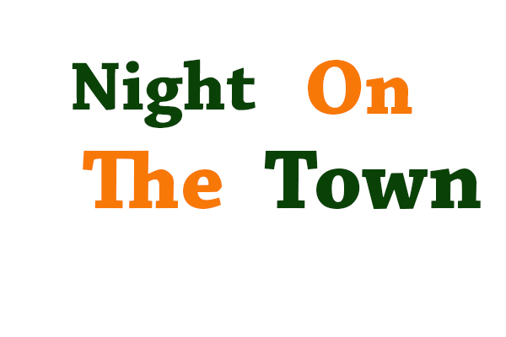
Details
Font-size- 48 pts
Font-colour- RGB: 10 66 06
RGB: 248 120 07

